Highly Specific Localization of Promoter Regions in Large Genomic Sequences by PromoterInspector: A Novel Context Analysis Approach
Matthias Scherf, Andreas Klingenhoff and Thomas Werner
Journal of Molecular Biology, 31 March 2000, Volume 297,Issue 3,Pages 599-606.
Abstract
We present a new algorithm called PromoterInspector to locate eukaryotic polymase II promoter regions in large genomic sequences with a high degree of specificity. PromoterInspector focuses on the genetic context of promoters, rather than their exact location. Application of PromoterInspector can serve as a crucial pre-processing step for other methods to locate exactly, or to analyze promoters.
- Introduction
Promoter prediction tools can roughly be divided in three groups: heuristic approaches; approaches that attempt to recognize core promoter elements such as TATA boxes, CAAT boxes and transcription initiation sites (INR); and approaches that attempt to use the whole ensemble of elements(transcription factor binding sites, oligonucleotides),found in a promoter.
- Results
Design of the prediction system
Definition of context features
Context features are defined by disjunct groups of similar IUPAC words. As an example, a IUPAC group which results from two wildcards and the oligonucleotide set (AGC,GCA) is (AGCGCA, AGCNGCA, AGCNNGCA).
Definition of decision instances
A classifier is defined by two disjunct sets of IUPAC groups: a set of promoter-related IUPAC groups defines the class “promoter” while a set of non-promoter-related IUPAC groups defines the class “non-promoter”
IUPAC group candidates example: a set of two oligonucleotides of length two and two wildcards. Training sequence AGCTG: (AGCT, AGNCT, AGNNCT), (AGTG,AGNTG,AGNNTG), (GCTG, GCNTG, GCNNTG).
Architecture of the prediction system
PromoterInspector is based on three classifier. Each classifier is specialized to differentiate between promoter and one of the following non-promoter sequences sets: exon, intron and 3’-UTR.
Parameter optimization of prediction system
- Discussion
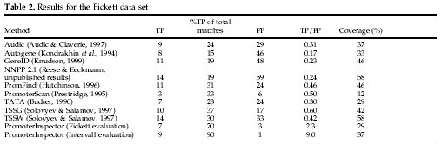
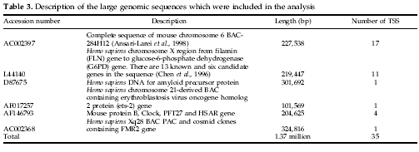

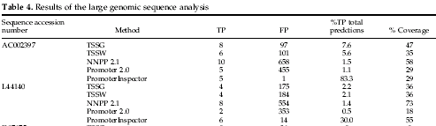
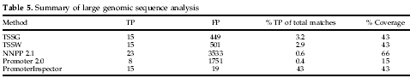
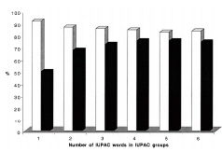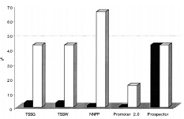

Created by: Huei-Ming Yang
Date: May 14,2004

